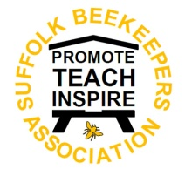
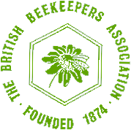
Suffolk Beekeepers’ Association
www.suffolkbeekeepers.co.uk
(An Area Association of the British Beekeepers’ Association)

County Committee Meeting

Minutes
26th January 2022

Attendees: Helen Davies, Chris Poupard, Ian McQueen, Jane Corcoran, Laraine Kuntze, Roger Chapman, Terry Avery, David Martin, Jackie McQueen, Jeremy Quinlan

# | Item | Who
1 | Apologies  Received from Joy Allen, Kevin Thorn | All
2 | Election of Chair  JQ was nominated & approved to chair the meeting | All
3 | Matters arising from previous minutes  Minor amendments were made to the minutes which were then approved. | All
4 | Treasurer’s Report  - The SBKA balance is healthy at £10,758.22.  - £510 has been passed on to the EARS programme on behalf of SCBKA & SDBKA branches.  - The expenses policy has been in force since 2018, should this be revised?  - There are no current plans for funding any projects that are not self-financing. | I McQ
5 | Membership Report  Over 600 members have been uploaded. JMc stated that the direct debit system although convenient, means receipt of monies tends to be delayed until the January. | J McQ
6 | 2022 ADM  No update | KT
7 | Education Update  JC hoping to run a ‘Bee Disease Day’ trying to agree a date with the speaker. Will try to run the basic course online for the county and offer practical sessions in addition. JQ discussing running a General Husbandry course with JC this year, currently writing a plan for the 3 days. | JC
8 | EARS Update  JT updated the meeting. CP stated that they may be able to donate. | JQ/JT
9 | Suffolk Show 2022  - Update: Plans are starting to take shape, we have paperwork from the showground now as well. Having met with the show directors in December they are very positive and supportive of what we do at the show which is always good to hear. We also have Mark Dua on our team who is shadowing Joy and plans to takeover for 2023. More news to follow as plans develop, no expenses at the moment. CP suggested including a class for 12oz jars – to send details to HD; light/medium honey, set honey in hexagonal 340g jars. HD commented that no feedback has been received on the last show’s schedule to date. Written comments annotated on the schedule are preferred.  - Expenses for show team: All agreed that reasonable expenses e.g. petrol would be paid | JA
10 | Alan Seager – Commemoration  RC commented that a bursary for young beekeepers (~£400pa) had been discussed but felt that it was more appropriate that the award come at a county level rather than directly from Stowmarket. JC suggested involving the parent as well so they can assist – a parent/child day has been offered before. A suggestion was made to offer the bursary to those who would not normally have the ability to take up beekeeping due to financial constraints. RC agreed to progress this. | JQ
11 | AOB  - JC received information on free magazines for new beekeepers  - New microscopy course setting up in Crowfield – JQ to send email to HD for inclusion in the minutes. Microscopes will be provided.  - AGM proposed for Thu 17Mar22 via Zoom. Officers to be nominated. HD to compile paperwork by end Feb. Annual reports from associations to be supplied two weeks (or more) before the AGM.  - The NHS have asked if we want to leave our Suffolk classes as is or change them. All agreed that the classes were sufficient. | All
12 | Proposed date and place of next meeting – Thu 17Mar22 - AGM | All
13 | Branch Reports (Submitted before meeting so they can be circulated prior to the meeting) | All

County Reports

SCBKA report

We are now planning our Beginners Course, with theory sessions by zoom and practical sessions at our teaching apiary, COVID permitting. This format worked quite well last year, though we were limited to the rule of six at the apiary. Strong demand for the course again with up to 20 interested.
Our AGM will take place on Saturday 19th March at Darsham Village Hall at 12 noon followed by a snack lunch. WE are planning an auction of used equipment after lunch, hopefully outside. The Hall will be open from 10am to allow delivery of items for sale. Further details will be circulated.
So far our programme will be centred around advice for improvers, with an early session on swarming and swarm control tba. Seasonal advice to all members has been circulated online on a bimonthly basis.
We would like to return to holding a summer bee safari, again dependent on COVID.

SDBKA Report
Like our fellow beekeepers in Norwich it's been a strange year - again. In 2021 despite the Covid restrictions we managed to train 20 new beekeepers including a few small face to face training sessions at our Baylham apiary. Most of the meetings were held via Zoom these have not been particularly well attended, even though we've sent Zoom setup instructions with each invitation. We had a great hog roast in September, the weather was marvellous and we had a good turnout; our members had just been itching for the opportunity to mingle. This was followed in October with the President's Tea again well attended. Our Christmas meeting was unfortunately called off, the Omicron variant was in full swing by then. On a brighter note we will be having our AGM on the 20th February 2022 and it's going to be a face to face meeting. We'll be seeking new committee members especially since our President, Tony Payne, is stepping down this year. Fortunately, Richard Martin has agreed to stand for President. Our beginner training starts 24th February 2022 and, fingers crossed, will be face to face and runs for 4 consecutive Thursday evenings.

NDBKA
We are a small, relatively new association with an enthusiastic committee which had just started to have an increased membership, with plans for the future when Covid cramped our style somewhat. Despite the lockdown our membership grew to 70 which took us all by surprise.
We have just held our AGM and as no new nominations were forthcoming (!) the three main post holders agreed to stand for one more year. However, we have been fortunate to have some additional co-opted members who will take on the new roles of Events Co-ordinator, Webmaster, Programme co-ordinator and Apiary Manager.
We are hoping to set up an association apiary this year and are waiting to have confirmation of a site at the University of East Anglia. This will be a great asset as we do have a large number of new beekeepers who will greatly benefit from some practical experience. Hopefully this will lead on to running courses for beginners.
We are also aiming to better match members who have asked for help to those who have offered it.
We enjoyed some excellent speakers last year.
2022 started well with Richard Noel, a bee farmer working in France, giving a hugely enjoyable talk after our AGM.
Our main aim for 2022 is for NDBKA to flourish and support our new beekeepers.

I&ESBKA
Although the BBKA will be increasing fees by £2 in 2022, as we have assets of £22k we will absorb half that increase.
We have held one face-to-face meeting (on Playing with Beeswax), otherwise Zoom meetings continue, once or twice a month. We intend that our 2 Feb AGM and talk by Peter Davies, our new RBI, will be face-to-face in the Kesgrave Scout Hall. As ever, members of other Suffolk BKAs are welcome to attend our meetings.
Helen Thorne, one of our trustees, has begun to visit as many primary schools as possible, emphasising the virtues and value of beekeeping.
Individual members continue our support for the beekeeping activities of the charity ActivLives and at HM Prisons Warren Hill and Hollesley Bay.
We have more than 300 books & DVDs in our library; borrowers may have them sent out by post; the understanding is that they return them - either at a face-to-face meeting or by mail at their expense.
Our “Introduction to Beekeeping” course starts on 28th February. So far 26 have signed up. If more apply, we will take up to 30.
When paying their annual subscription, members are asked if they would like a mentor – obviously, this is for new and inexperienced beekeepers - or if they would be happy to be one. While applications exceed volunteers, we do what we can.
We are planning our summer Sunday afternoon apiary openings at Wherstead and considering how we can show the inexperienced how best to keep bees.
Also at our Wherstead apiary meetings, we plan to offer instruction in advancing the skills of the more experienced who want that.
On 18th June - the day the nation celebrates Her Majesty’s Platinum Jubilee – we shall be holding an afternoon Hog Roast to celebrate our 141st birthday at our Wherstead apiary. All Suffolk beekeepers will be invited to come. So that we can be sure how many really do mean to attend, there will be a small charge – yet to be decided. Two complimentary double tickets will be offered to the other five Suffolk Associations; children will be welcome.
David Caldwell celebrated 80 years of beekeeping in 2021. There will be a presentation to him – he does not yet know this – we hope at the Hog Roast - not far from his home.
We are planning to hold an Apiary Safari in the Felixstowe/Kirton area on a Saturday - probably in July. I expect to be able to tell you the date when we meet.

Treasurers Report

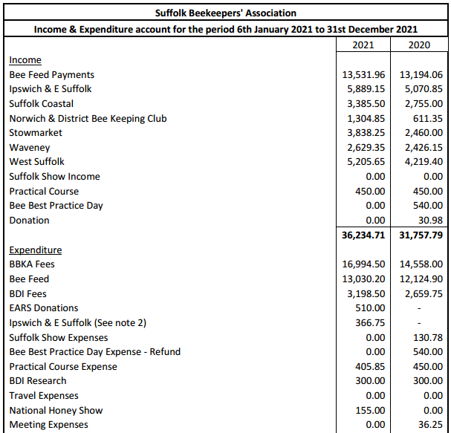
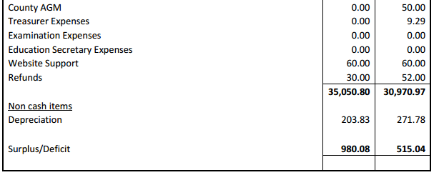

AOB – Additional Info re #2

